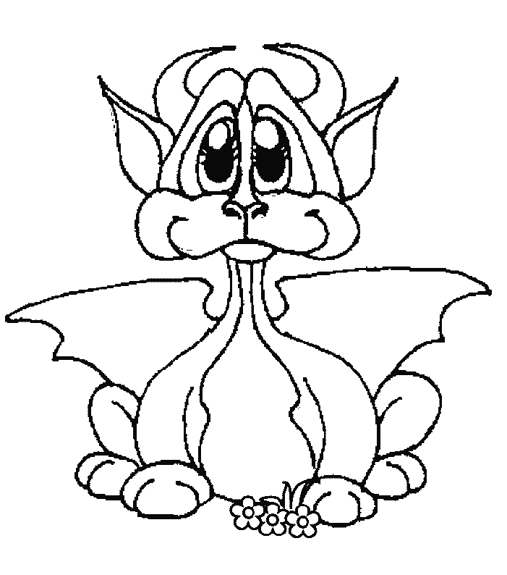

www.picturesforcoloring.com www.alvasachs.com
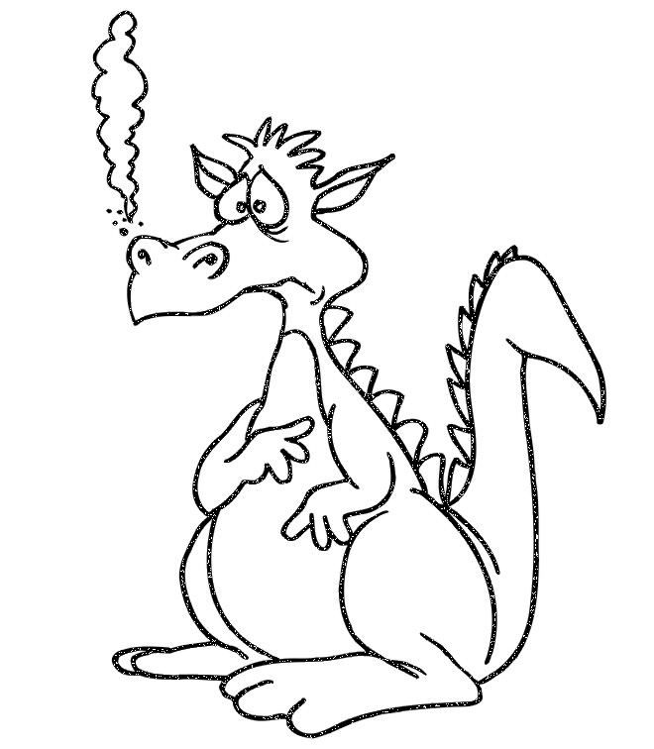

www.picturesforcoloring.com www.alvasachs.com

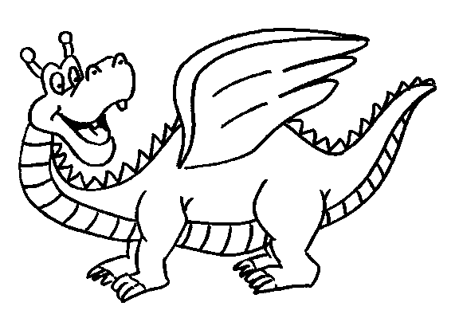

www.picturesforcoloring.com www.alvasachs.com
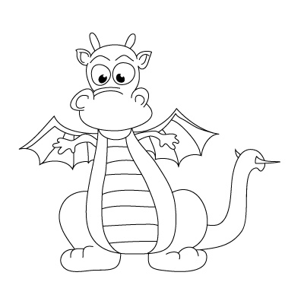

www.picturesforcoloring.com www.alvasachs.com

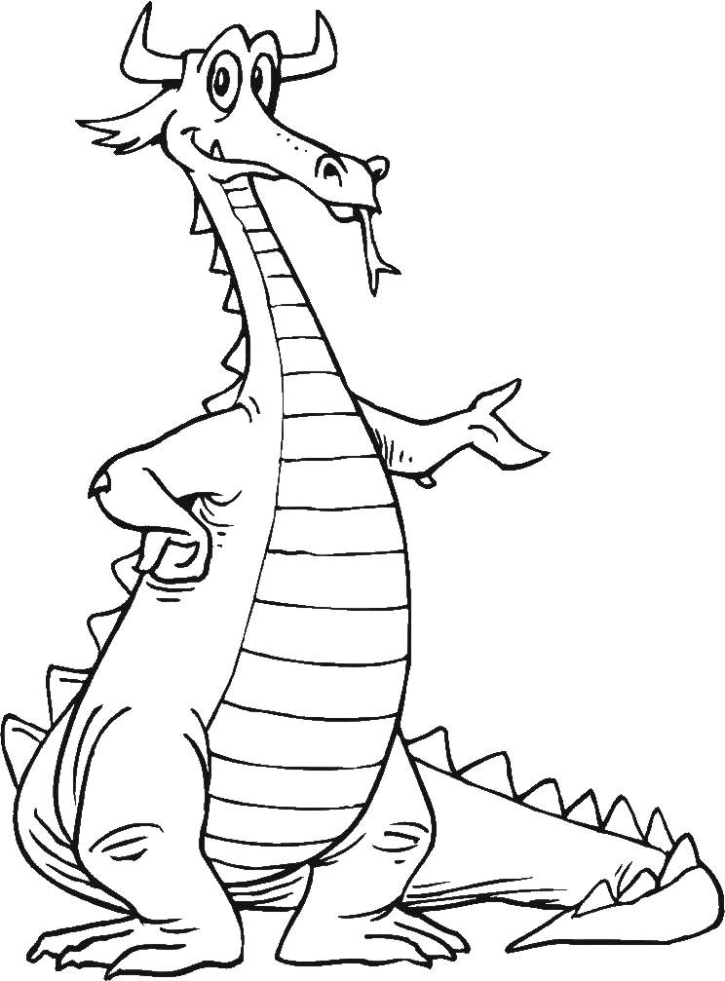

www.picturesforcoloring.com www.alvasachs.com

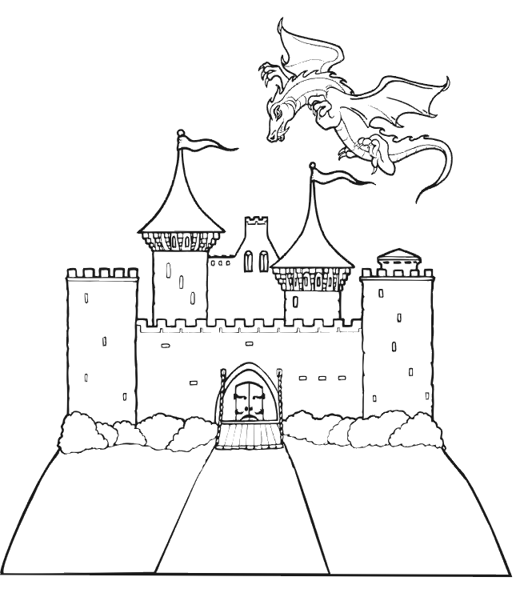

www.picturesforcoloring.com www.alvasachs.com

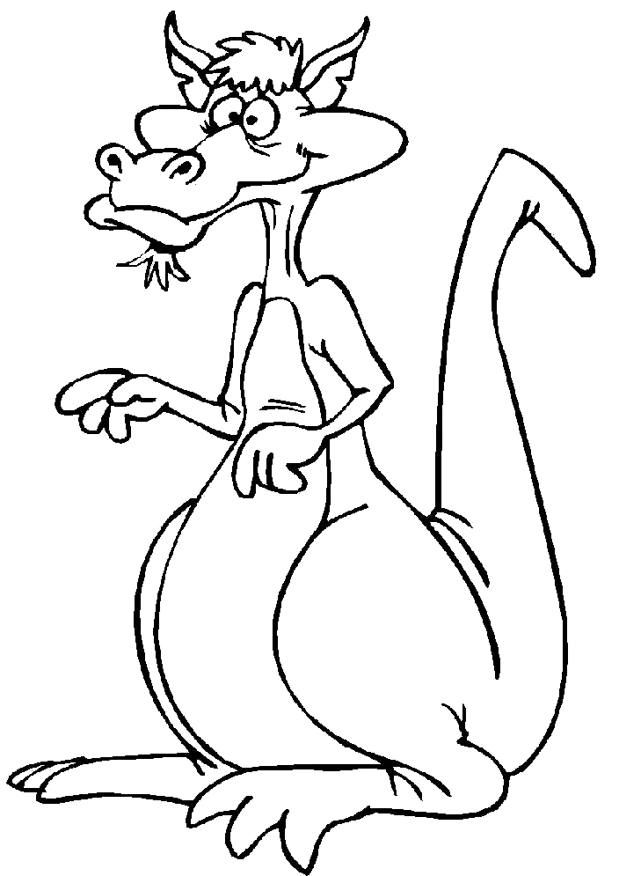

www.picturesforcoloring.com www.alvasachs.com

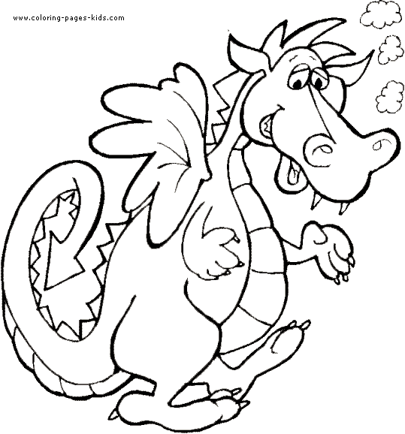

www.alvasachs.com

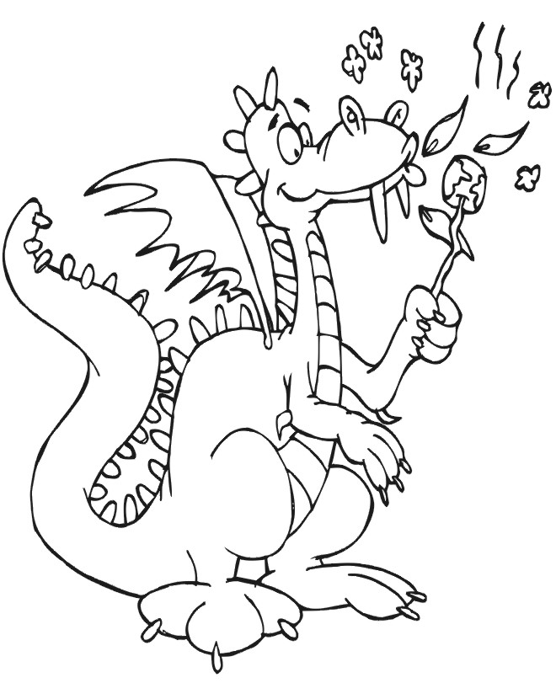
www.picturesforcoloring.com www.alvasachs.com
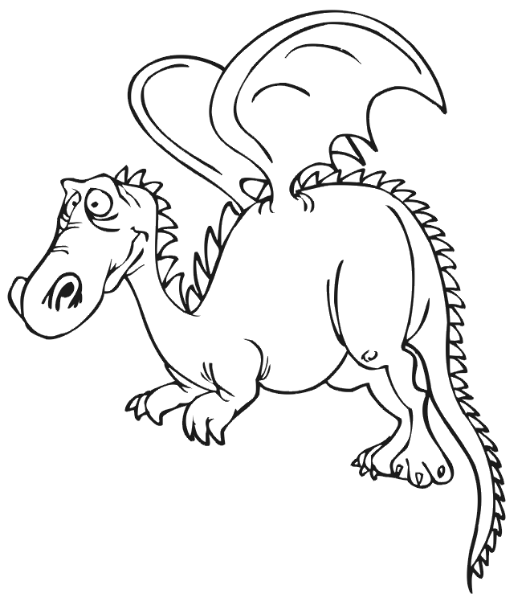

www.picturesforcoloring.com www.alvasachs.com

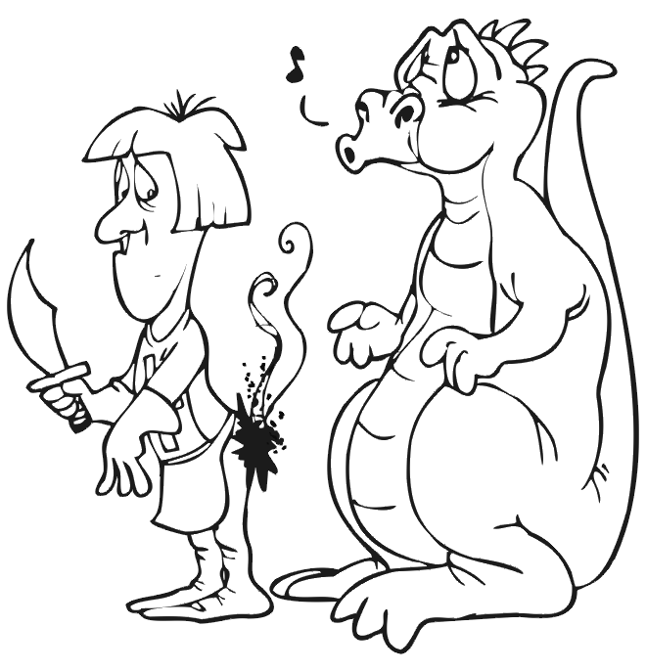

www.picturesforcoloring.com www.alvasachs.com

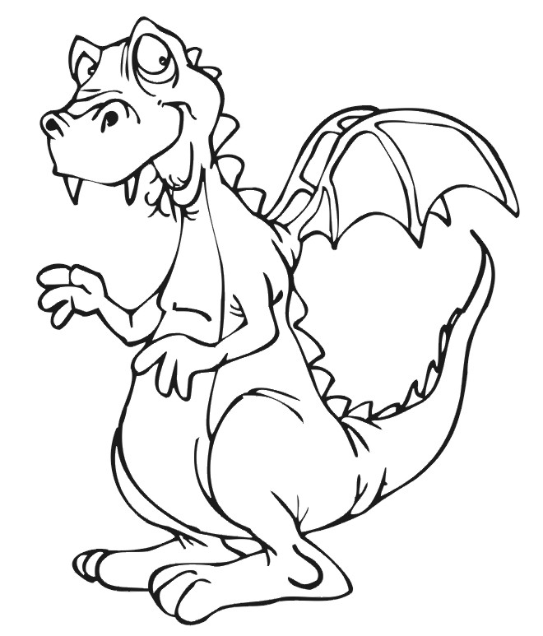

www.picturesforcoloring.com www.alvasachs.com

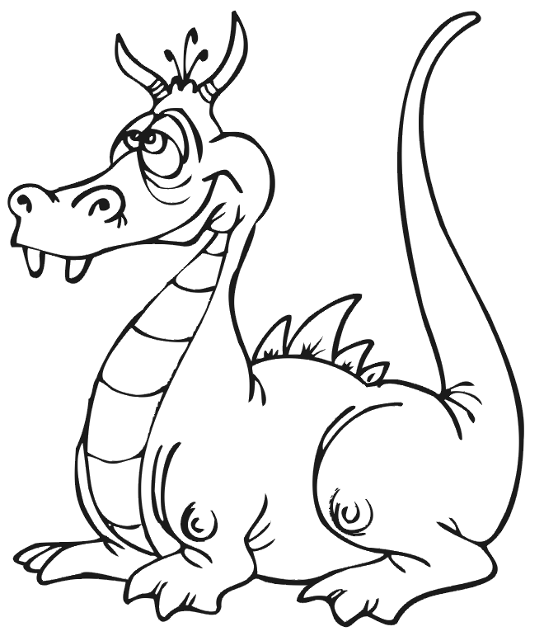

www.picturesforcoloring.com www.alvasachs.com
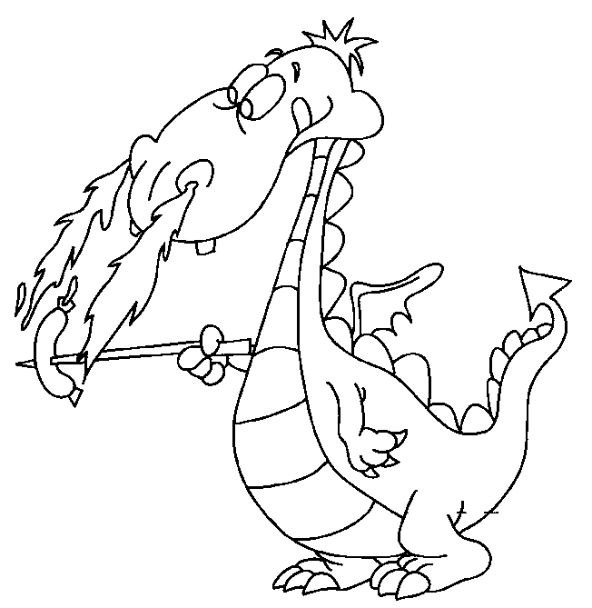

www.picturesforcoloring.com www.alvasachs.com
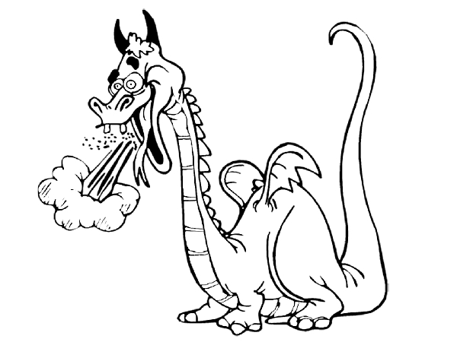

www.picturesforcoloring.com www.alvasachs.com

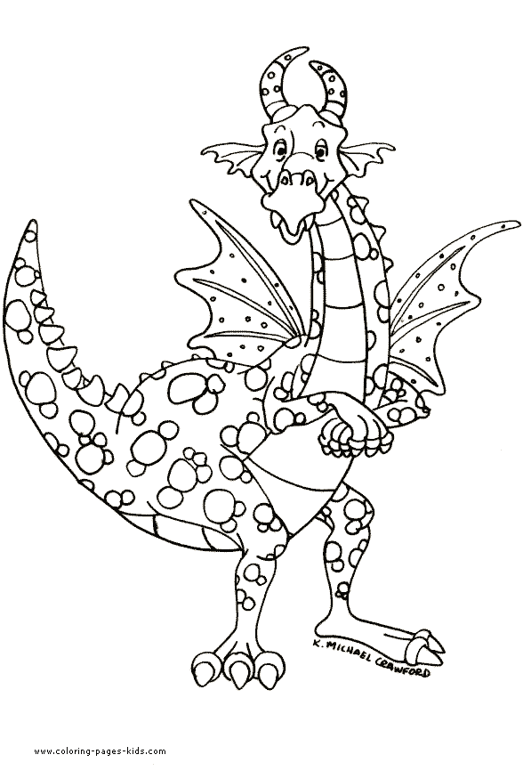
www.alvasachs.com

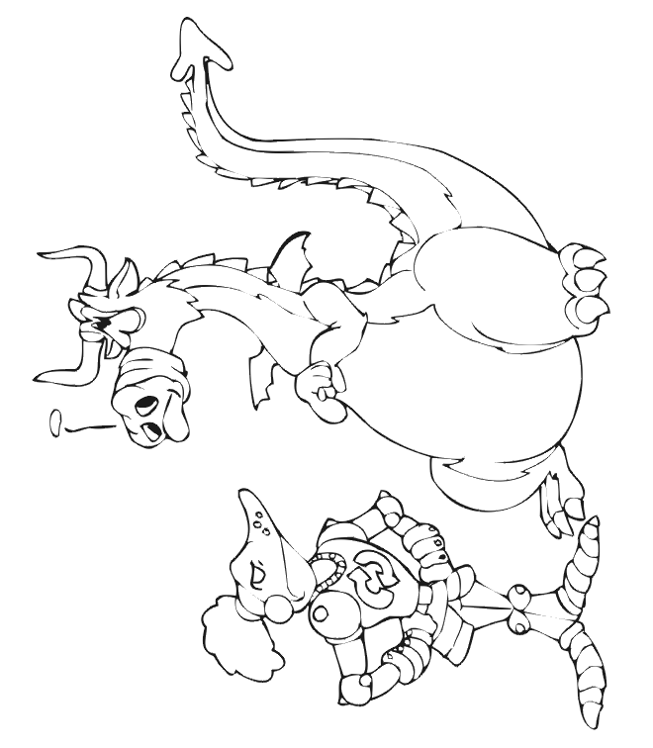

www.alvasachs.com

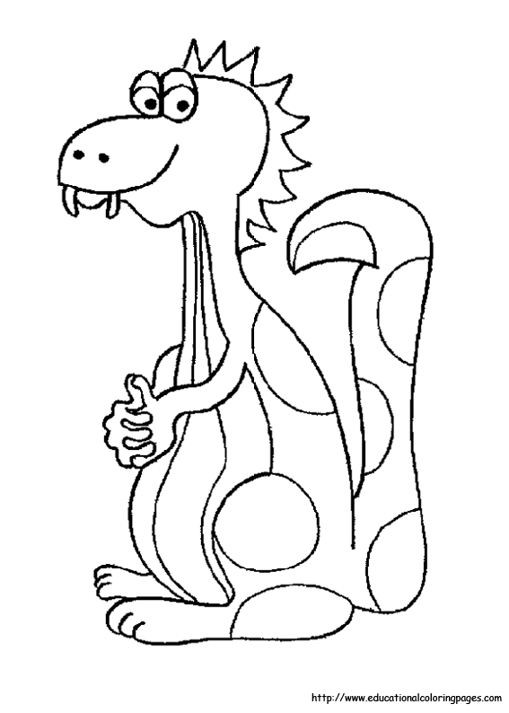

www.alvasachs.com

www.alvasachs.com

